Unit – III (MONEY AND TEAM)

Revenue Streams - Basics of how companies make money

Companies make money through revenue streams, which are the different ways they generate income. Here are the basic revenue streams businesses use:

1. Product Sales 🛍️
Companies sell physical or digital products directly to consumers.
Example:
- Apple sells iPhones and MacBooks.
- Nike sells shoes and apparel.

2. Service Revenue 💼
Businesses earn money by providing services instead of products.
Example:
- A consulting firm charges for advisory services.
- A gym charges membership fees.

3. Subscription Model 🔄
Customers pay a recurring fee (monthly or yearly) for access to a product or service.
Example:
- Netflix charges a monthly fee for streaming.
- Spotify offers premium subscriptions for ad-free music.

4. Advertising Revenue 📢
Companies make money by displaying ads to users.
Example:
- Google earns from businesses running ads on its platform.
- YouTube earns from advertisers who pay to show ads before videos.

5. Licensing & Royalties 🏷️
Businesses earn money by allowing others to use their intellectual property (IP).
Example:
- Microsoft licenses its Windows OS to PC manufacturers.
- Musicians earn royalties when their songs are played on Spotify.

6. Commission & Brokerage Fees 💰
Companies act as middlemen and take a percentage of sales.
Example:
- Amazon takes a commission on every product sold by third-party sellers.
- Uber takes a cut from each ride booked through its app.

7. Affiliate Marketing 🔗
Businesses earn a commission by promoting other companies' products.
Example:
- Influencers earn commissions by promoting Amazon products.
- Websites recommend products and get paid for each sale made through their links.

8. Data Monetization 📊
Companies collect and sell user data to advertisers or researchers.
Example:
- Facebook and Google use user data to sell targeted ads.
- Credit bureaus sell consumer credit reports to banks.

9. Transaction Fees 💳
Companies charge a small fee for processing transactions.
Example:
- PayPal and Stripe charge businesses a fee per transaction.
- Visa and Mastercard earn from transaction fees on credit card payments.

Understanding Companies’ Income, Costs, Gross Margin, and Net Margin
Businesses make money through various revenue streams, but their financial success depends on how they manage income and costs. Let’s break it down step by step.

1. Revenue (Income) – The Money Coming In
Revenue (also called sales or turnover) is the total amount of money a company earns before subtracting any costs.

Types of Revenue:
- Operating Revenue – Money from the company’s main business (e.g., Apple selling iPhones, Netflix subscriptions).
- Non-Operating Revenue – Money from secondary activities (e.g., interest on investments, asset sales).
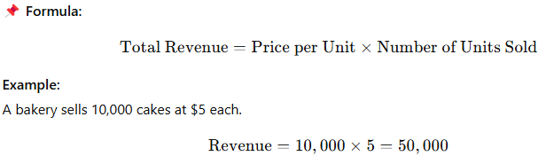

2. Costs – The Money Going Out

Types of Costs:

A. Fixed Costs (FC) – Do Not Change with Sales
These remain constant, regardless of how much the company produces or sells.
🔹 Examples:
- Rent
- Salaries of permanent staff
- Insurance
- Depreciation of equipment

B. Variable Costs (VC) – Change with Sales Volume
These depend on how many units a company produces or sells.
🔹 Examples:
- Raw materials
- Packaging
- Shipping
- Sales commissions
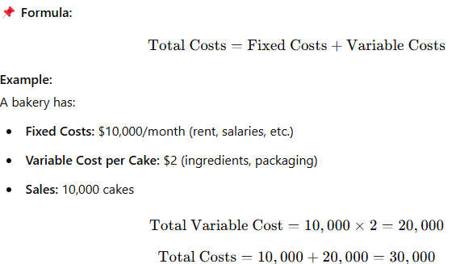

3. Gross Margin – How Much Profit from Sales Before Expenses
Gross Profit is the money left after subtracting only the direct costs (Cost of Goods Sold or COGS) from revenue.
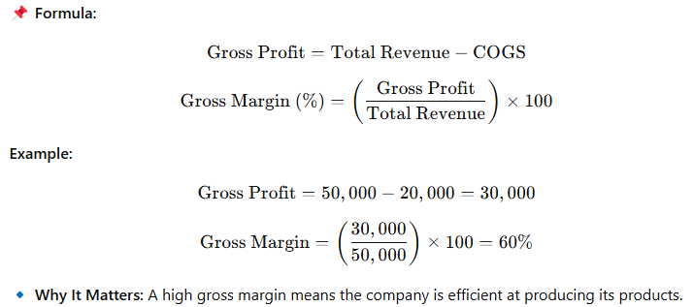

4. Net Margin – The Final Profit After All Expenses
Net profit is the money left after deducting all expenses (fixed costs, variable costs, taxes, interest, etc.) from revenue.
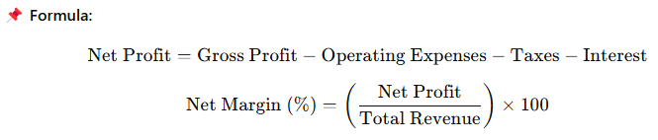
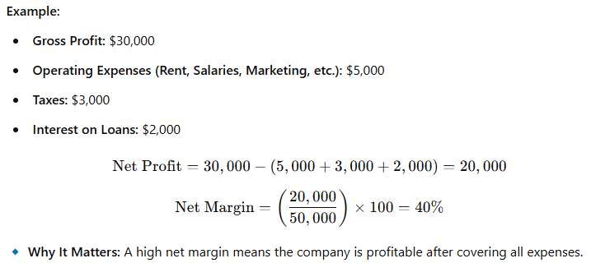

Summary Table
Metric | Formula | Meaning
Revenue (Sales) | Price × Quantity | Total money earned before costs
Total Costs | Fixed Costs + Variable Costs | Total money spent to run the business
Gross Profit | Revenue - COGS | Money left after direct costs
Gross Margin (%) | (Gross Profit / Revenue) × 100 | Profitability before expenses
Net Profit | Gross Profit - Operating Expenses - Taxes - Interest | Final profit after all expenses
Net Margin (%) | (Net Profit / Revenue) × 100 | Final profit percentage

Key Takeaways
✔ Revenue is NOT profit – A company can have high sales but still lose money if costs are too high.
✔ Gross Margin tells efficiency – A high percentage means a company produces goods efficiently.
✔ Net Margin tells overall profitability – It shows how much money remains after covering all expenses.
✔ Higher margins mean better profitability – Investors and business owners track margins to assess success.

Identify Primary and Secondary Revenue Streams for a Company
Understanding a company's primary and secondary revenue streams helps in assessing its business model, financial health, and risk diversification. Here's how you can identify them:

1. Primary Revenue Stream 💰
The primary revenue stream is the main source of income for a company, contributing the largest portion of its total revenue.

How to Identify the Primary Revenue Stream
✅ Look at the Core Product or Service
- What is the company best known for?
- What is its main offering?
✅ Check Financial Reports (If Available)
- Companies disclose revenue breakdowns in financial reports or investor presentations.
✅ Analyze Market Positioning
- What do customers primarily buy from this business?
✅ Observe Pricing Models
- Is revenue generated from one-time sales, subscriptions, or transactions?
📌 Examples of Primary Revenue Streams:
Company | Industry | Primary Revenue Source
Apple | Technology | iPhone sales
Amazon | E-commerce | Online product sales
Netflix | Entertainment | Subscription fees
McDonald's | Fast Food | Food & beverage sales

2. Secondary Revenue Stream 💡
The secondary revenue stream is a smaller but significant source of income that complements the primary business model.

How to Identify a Secondary Revenue Stream
✅ Look for Additional Products or Services
- What else does the company offer besides its main product?
- Are there premium upgrades or add-ons?
✅ Check for Alternate Monetization Methods
- Does the company earn through advertising, partnerships, or data sales?
✅ Analyze Business Diversification
- Does the company have revenue from licensing, franchising, or consulting?
📌 Examples of Secondary Revenue Streams:
Company | Primary Revenue | Secondary Revenue
Apple | iPhone sales | App Store fees, iCloud subscriptions
Amazon | Online product sales | Amazon Prime memberships, AWS cloud services
Netflix | Subscriptions | Licensing content, partnerships
McDonald's | Food sales | Franchising fees, real estate

3. Why Identifying Revenue Streams Matters
✔ Business Stability – A company with multiple revenue streams is more financially stable.
✔ Growth Opportunities – Identifying secondary revenue streams can help expand income.
✔ Investment Decisions – Investors analyze revenue sources to assess a company’s profitability and risk.

Understanding Pricing and Costs: Value, Price, and Costs
Pricing a product or service correctly is critical for business success. It involves understanding costs, perceived value, and competitive pricing strategies. Let’s break it down:

1. Value – What the Customer Perceives 💡
Value is how much a customer believes a product or service is worth. It is subjective and influenced by:
✔ Quality & Features – A premium smartphone is more valuable than a basic one.
✔ Brand Reputation – Apple can charge more due to brand trust.
✔ Customer Experience – Personalized services add value.
✔ Convenience & Accessibility – Faster delivery or exclusive access increases value.
📌 Example:
- A luxury watch (Rolex) is valued higher than a regular one, not because it tells time better but due to branding, exclusivity, and craftsmanship.

2. Price – What the Customer Pays 💰
Price is the monetary amount a customer is willing to pay. It is determined by:
✅ Production Costs – How much it costs to make.
✅ Market Demand – High demand allows higher pricing.
✅ Competitor Pricing – Prices are adjusted based on competitors.
✅ Brand Perception – Premium brands can charge more.
📌 Formula:
Price = Cost + Markup (Profit Margin)
📌 Example:
- iPhone 15 costs $500 to manufacture but is priced at $1,000 due to branding and perceived value.

3. Cost – The Money Spent to Make the Product 🏭
Cost is the total expense incurred to produce and sell a product.

Types of Costs
✔ Fixed Costs (FC) – Do Not Change with Production
- Examples: Rent, salaries, insurance, equipment.
- Even if no units are sold, these costs remain.
✔ Variable Costs (VC) – Change with Production
- Examples: Raw materials, packaging, shipping, commissions.
- Increase as more units are sold.
📌 Formula:
Total Cos = Fixed Costs + Variable Costs
📌 Example:
A company makes 100 shirts:
- Fixed Costs: $1,000 (rent, salaries)
- Variable Cost per Shirt: $5
- Total Variable Cost: $5 × 100 = $500
- Total Cost: $1,000 + $500 = $1,500

4. Relationship Between Value, Price, and Cost 🔄
Factor | Definition | Example
Value | Customer’s perceived worth | Rolex is seen as a luxury item
Price | What the customer pays | Rolex costs $10,000
Cost | Money spent to produce the product | Rolex production cost = $2,500
📌 Key Takeaway:
- High Value, Low Cost → High Profits
- Low Value, High Price → Customers Won’t Buy
- High Costs, Low Price → Losses

5. Pricing Strategies
1️⃣ Cost-Plus Pricing – Price = Cost + Profit Margin.
2️⃣ Value-Based Pricing – Based on customer perception.
3️⃣ Competitive Pricing – Priced based on competitors.
4️⃣ Penetration Pricing – Low initial price to gain market share.
5️⃣ Premium Pricing – High price for exclusivity.
📌 Example:
- McDonald's → Cost-Plus Pricing
- Tesla → Value-Based Pricing
- Amazon → Competitive Pricing

Final Thoughts
✔ Cost affects profitability but doesn’t define price.
✔ Value drives pricing – If customers see more value, they’ll pay more.
✔ Balancing cost, price, and value is the key to success.

Understanding Pricing, Product Costs, and Operational Costs
To price a product correctly, businesses must understand different pricing strategies, how to calculate product costs, and manage operational costs.

1. Different Pricing Strategies 💰
Pricing strategies depend on factors like costs, market demand, and competition. Here are the main types:

A. Cost-Based Pricing
✔ Cost-Plus Pricing – Add a fixed percentage to the cost.
✔ Break-Even Pricing – Price set to cover costs.
📌 Example:
- A product costs $10 to make, and the company wants a 30% profit margin.
Price = 10 + (10 × 0.30) = 13

B. Market-Oriented Pricing
✔ Competitive Pricing – Based on what competitors charge.
✔ Penetration Pricing – Low price to attract customers initially.
✔ Premium Pricing – High price for luxury or exclusivity.
📌 Example:
- Apple uses premium pricing, charging more due to brand perception.
- Amazon uses competitive pricing to match or undercut competitors.

C. Value-Based Pricing
✔ Price is set based on perceived customer value rather than cost.
✔ Works well for unique, high-demand products.
📌 Example:
- Nike sneakers may cost $20 to make but are priced at $100+ due to branding and customer loyalty.

D. Dynamic & Psychological Pricing
✔ Dynamic Pricing – Prices change based on demand (e.g., airline tickets).
✔ Psychological Pricing – Uses tactics like $9.99 instead of $10 to seem cheaper.

📌 Example:
- Uber’s surge pricing increases fares when demand is high.
Pricing Strategy | Description | Example
Cost-Plus Pricing | Adding a fixed percentage to the production cost. | Manufacturing cost ₹100 + 20% margin = ₹120 price.
Value-Based Pricing | Pricing based on perceived customer value. | Apple charges premium prices for iPhones based on brand and innovation.
Penetration Pricing | Setting a low initial price to attract customers. | Jio offered free internet to gain market share before introducing paid plans.
Skimming Pricing | Charging a high price initially, then lowering it over time. | New iPhone models launch at high prices, which decrease later.
Freemium Pricing | Offering a free product with paid upgrades. | Zoom provides free basic video calls but charges for premium features.
Dynamic Pricing | Adjusting prices based on demand and competition. | Airlines and hotel bookings change prices based on availability.

2. Understanding Product Costs 🏭
Product cost = Direct costs to make a product

Types of Product Costs:
🔹 Direct Materials – Raw materials used (e.g., cotton for T-shirts).
🔹 Direct Labor – Wages of workers making the product.
🔹 Manufacturing Overheads – Machine maintenance, utilities, packaging.
📌 Formula:
Total Product Cost = Direct Materials + Direct Labor + Manufacturing Overhead
📌 Example:
For a T-shirt business:
- Fabric cost: $3
- Labor cost: $2
- Factory expenses: $1
- Total product cost: $3 + $2 + $1 = $6 per unit

3. Understanding Operational Costs 🏢
Operational costs (OPEX) = Costs of running the business daily

Types of Operational Costs:
🔹 Fixed Costs – Stay the same regardless of sales (e.g., rent, salaries).
🔹 Variable Costs – Change with production (e.g., raw materials, shipping).
🔹 Semi-Variable Costs – A mix of both (e.g., utility bills with a base charge + usage fees).
📌 Example:
A bakery has:
- Fixed costs: $5,000 (rent, salaries)
- Variable costs per cake: $2 (ingredients, packaging)
- If they sell 1,000 cakes:
Total Cost = 5,000 + (2 × 1,000) = 7,000

4. Relationship between Pricing, Costs, and Profits
Factor | Definition | Example
Product Cost | Direct costs of making the product | Raw materials, labor
Operational Cost | Costs of running the business | Rent, salaries, marketing
Price | What the customer pays | Market-based decision
Profit | Revenue - Costs | How much the company keeps
📌 Formula for Profit:
Profit = Revenue − (Product Costs + Operational Costs)

Final Thoughts
✔ Pricing must cover both product & operational costs to be profitable.
✔ Value-based pricing can help maximize profits beyond just cost calculations.
✔ Monitoring costs helps businesses stay competitive and efficient.

Basics of Unit Costing Strategies
Unit costing is the calculation of the cost per unit of a product or service. This helps businesses determine pricing, profitability, and cost control.

1. What is Unit Cost?
📌 Unit Cost Formula:
Unit Cost = Total Production Cost / Number of Units Produced
📌 Example:
A factory produces 1,000 shoes at a total cost of $50,000:
Unit Cost = 50,000 / 1,000 = 50 per shoe

2. Components of Unit Cost
Unit cost includes fixed costs, variable costs, and overhead costs.

A. Fixed Costs (FC) – Do Not Change with Production
✔ Rent, salaries, insurance, equipment depreciation.
✔ Even if zero units are produced, these costs remain.

B. Variable Costs (VC) – Change with Production
✔ Raw materials, packaging, shipping, direct labor.
✔ Increase as more units are made.
📌 Total Cost Formula:
Total Cost = Fixed Costs + (Variable Cost per Unit × Units Produced)
📌 Example:
A bakery has:
- Fixed Costs: $5,000
- Variable Cost per Cake: $2
- Produces 1,000 cakes
Total Cost = 5,000 + (2 × 1,000) = 7,000

Unit Cost = 7,000 / 1,000 = 7

3. Unit Costing Strategies

A. Cost-Plus Pricing (Markup Pricing)
✔ Add a profit margin on top of unit cost.
✔ Used in retail, manufacturing, and food industries.
📌 Formula:
Price = Unit Cost + (Unit Cost × Profit Margin)
📌 Example:
If unit cost = $7, and markup = 40%, then:
Price = 7 + (7 × 0.40) = 9.80

B. Marginal Costing
✔ Focuses on variable costs only for pricing decisions.
✔ Used for special discounts, seasonal pricing.
📌 Example:
- If fixed costs are covered, a business can sell extra units at a lower price, covering only variable costs.

C. Absorption Costing
✔ Includes both fixed and variable costs.
✔ Required for financial reporting.
📌 Example:
- Total Fixed Costs: $10,000
- Total Variable Costs: $5 per unit
- Units Produced: 2,000
Unit Cost = (10,000 + (5 × 2,000)) / 2,000​ = 10

D. Activity-Based Costing (ABC)
✔ Allocates costs based on actual activities (e.g., machine hours, labor time).
✔ Used in custom manufacturing and service industries.
📌 Example:
If setup cost per batch is $500, and each batch has 100 units, then the setup cost per unit = $5.

4. Importance of Unit Costing
✔ Helps in Pricing – Ensures a profit margin.
✔ Aids in Cost Control – Identifies high-cost areas.
✔ Improves Profitability – Lower unit costs increase margins.
✔ Essential for Decision Making – Used in scaling and expansion plans.

Final Thoughts
✔ Understanding fixed and variable costs is key.
✔ Choosing the right costing strategy depends on business needs.
✔ Lowering unit costs increases competitiveness & profitability.

Problems:
1. If a business sells a product for ₹1,500 and its cost of goods sold (COGS) is ₹600, calculate the gross profit and gross margin percentage.
Solution:
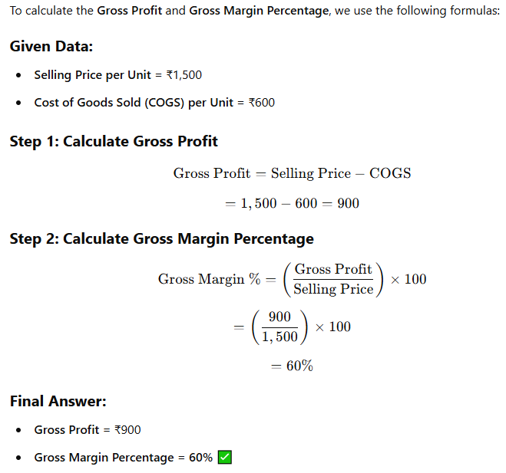

2. A clothing company incurs ₹50,000 in fixed costs and a variable cost of ₹200 per unit. If each unit is sold for ₹500, how many units must be sold to break even?
Solution:
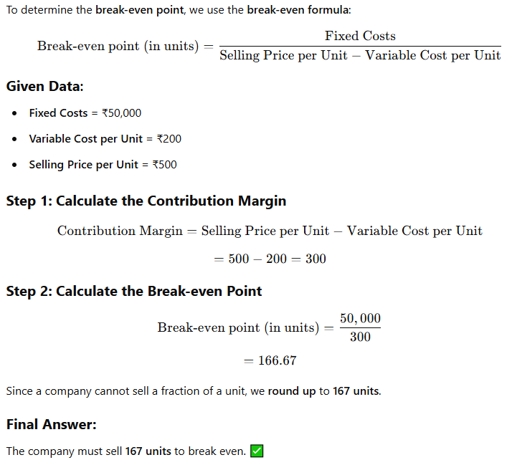

Financing Your New Venture
Starting a business requires capital, and understanding how to finance your business idea is crucial for success. Entrepreneurs have multiple financing options, each with its own advantages and challenges.

1. How to Finance Business Ideas
Financing a business involves:
✅ Estimating startup costs (e.g., product development, marketing, operations).
✅ Choosing the right funding source based on needs.
✅ Preparing financial projections to attract investors.
✅ Pitching the idea effectively to secure funding.

2. Various Sources of Funds for Entrepreneurs
Entrepreneurs can raise money through self-funding, loans, investors, or grants.

A. Self-Funding (Bootstrapping)
✔ Using personal savings or revenue from early sales.
✔ Avoids giving up equity or taking on debt.
✅ Pros:
✔ Full control of the business.
✔ No debt or investor interference.
❌ Cons:
✘ Limited capital.
✘ Higher personal financial risk.
📌 Best for: Small businesses, early-stage startups.

B. Loans (Debt Financing)
✔ Borrowing money from banks, credit unions, or online lenders.
🔹 Bank Loans – Traditional option with structured repayments.
🔹 Government Loans (SBA, MSME, etc.) – Lower interest rates, longer repayment terms.
🔹 Business Credit Cards – Quick access to capital but high interest.
✅ Pros:
✔ Retain full ownership of the company.
✔ Interest payments are often tax-deductible.
❌ Cons:
✘ Must repay with interest, even if the business fails.
✘ Requires good credit and collateral.
📌 Best for: Stable businesses with predictable revenue.

C. Angel Investors
✔ Wealthy individuals investing in startups for equity.
✅ Pros:
✔ No repayment pressure like loans.
✔ Investors may offer mentorship and business connections.
❌ Cons:
✘ Giving up a portion of ownership.
✘ Investors expect high growth and fast returns.
📌 Best for: High-growth startups in early stages.

D. Venture Capital (VC) Funding
✔ Investment firms provide large amounts of funding for high-potential startups.
✅ Pros:
✔ Large capital investment to scale quickly.
✔ Access to expert guidance and networks.
❌ Cons:
✘ Loss of significant ownership and control.
✘ Pressure for rapid growth and exit strategy (IPO or acquisition).
📌 Best for: Tech startups, scalable businesses with strong growth potential.

E. Crowdfunding
✔ Raising small amounts from many people via platforms like Kickstarter, Indiegogo, or GoFundMe.
✅ Pros:
✔ No need to give up equity or take on debt.
✔ Can validate the product idea before launching.
❌ Cons:
✘ Success depends on strong marketing and social media.
✘ May not raise enough money.
📌 Best for: Consumer products, creative projects, and social ventures.

F. Grants & Competitions
✔ Non-repayable funding from governments, NGOs, and corporate programs.
✅ Pros:
✔ Free money with no repayment or equity loss.
✔ Often supports innovation and social impact.
❌ Cons:
✘ Highly competitive with strict eligibility.
✘ Lengthy application process.
📌 Best for: Research, social enterprises, and tech innovation.

3. What Investors Expect From You
To attract investors, entrepreneurs must demonstrate:
✅ A Solid Business Plan – Clear roadmap, market analysis, and revenue model.
✅ Scalability – A business model that can grow rapidly.
✅ Competitive Advantage – A unique product or service.
✅ Strong Financial Projections – Revenue forecasts and profitability timeline.
✅ A Capable Team – Founders with experience and execution ability.
✅ An Exit Strategy – How investors can make a return (IPO, acquisition).
📌 Example:
- A VC firm investing $1 million in a startup expects 10-50x returns within 5-7 years.

4. Practicing Your Pitch to Investors & Corporations

A. Key Elements of a Winning Pitch
1️⃣ Introduction: Who you are and what your company does.
2️⃣ Problem Statement: The issue your product/service solves.
3️⃣ Solution: How your business addresses the problem.
4️⃣ Market Opportunity: Size of your target market.
5️⃣ Business Model: How you make money.
6️⃣ Traction: Sales, users, partnerships, or any validation.
7️⃣ Team: Why your team can execute the vision.
8️⃣ Financials: Revenue projections, profitability, and funding needs.
9️⃣ The Ask: How much funding you need and how it will be used.
🔟 Closing: Call to action and investor engagement.

B. Tips for a Successful Pitch
✔ Keep It Short & Clear – Investors have limited time.
✔ Tell a Story – Make it relatable and engaging.
✔ Show Market Demand – Use real data and traction.
✔ Demonstrate ROI – Explain how investors will make money.
✔ Be Confident & Passionate – Investors invest in people, not just ideas.
📌 Example of a Pitch Opening:
"Hello, I'm Alex, founder of GreenTech, a startup revolutionizing sustainable energy solutions. Today, 80% of homes rely on non-renewable energy, causing high costs and pollution. Our innovative solar panels reduce costs by 40% and are affordable for middle-class households. We are seeking $500,000 to expand production and reach 10,000 homes within a year. Let me show you how we can transform the energy industry together."

Final Thoughts
✔ Choose funding sources wisely based on your business stage.
✔ Investors expect high returns, so prove scalability and profitability.
✔ A strong pitch can make the difference between getting funded or not.

TEAM

Team Building - Shared Leadership: A Detailed Explanation

Introduction to Shared Leadership in Team Building
Team building is a critical process that enhances collaboration, communication, and productivity within a group. One approach that has gained significant attention in modern workplaces is Shared Leadership. Unlike traditional leadership models where a single leader holds all decision-making power, shared leadership distributes leadership roles and responsibilities among team members based on expertise, strengths, and situational needs.
This concept fosters a more dynamic, engaged, and innovative team culture, making it highly relevant for organizations striving for agility, adaptability, and collective ownership of goals.

1. Understanding Shared Leadership
Shared leadership refers to a decentralized leadership approach where multiple individuals assume leadership roles at different times, depending on their skills and knowledge in a given situation. This model shifts the focus from a hierarchical structure to a collaborative environment where team members influence and inspire each other.

Key Characteristics of Shared Leadership
- Mutual Influence: Leadership is not assigned to one person but is distributed across the team.
- Dynamic Role Shifting: Leadership roles change based on expertise and the demands of a particular task or project.
- Collaboration & Trust: Strong relationships and trust among team members are essential for shared leadership to thrive.
- Empowerment & Accountability: Team members feel empowered to make decisions, leading to increased responsibility and accountability.
- Collective Decision-Making: Decisions are made based on collective insights rather than the authority of a single leader.

2. The Importance of Shared Leadership in Team Building

Why is Shared Leadership Important?
In traditional leadership structures, teams often rely on a single leader for guidance, which can lead to bottlenecks in decision-making and slow adaptation to change. Shared leadership, on the other hand, enhances:
- Innovation & Creativity: Encourages diverse perspectives and ideas.
- Engagement & Motivation: Employees feel a sense of ownership, leading to increased motivation.
- Adaptability & Agility: Allows teams to quickly respond to challenges and changes.
- Better Problem-Solving: Different viewpoints lead to more effective solutions.
- Improved Work Satisfaction: Employees experience higher job satisfaction due to their involvement in decision-making.

3. Key Elements of Shared Leadership in Team Building
To successfully implement shared leadership, organizations must focus on the following elements:

A. Trust & Psychological Safety
- Team members must trust each other’s abilities and intentions.
- A psychologically safe environment ensures that individuals feel comfortable sharing ideas without fear of judgment.

B. Role Fluidity & Flexibility
- Leadership roles should not be rigid but should change based on who is best suited for a task.
- Encouraging individuals to step up when their expertise is needed.

C. Open Communication & Active Listening
- Teams should foster a culture of transparency where members actively listen and communicate effectively.
- Regular team meetings, feedback loops, and open discussions enhance collaboration.

D. Empowerment & Decision-Making Authority
- Employees should be empowered to take initiative and make decisions.
- Micromanagement should be avoided, allowing team members to take ownership of their responsibilities.

E. Shared Vision & Common Goals
- A clear, shared vision aligns the team towards common objectives.
- Setting collective goals ensures that leadership efforts contribute to the team's overall success.

4. Implementing Shared Leadership in Team Building

Step-by-Step Approach
- Establish a Shared Purpose
  - Define the team’s mission, goals, and expected outcomes.
  - Ensure alignment with the organization’s broader objectives.
- Develop a Collaborative Culture
  - Promote teamwork, knowledge sharing, and mutual respect.
  - Conduct team-building activities that encourage trust and cooperation.
- Identify Strengths & Allocate Leadership Roles
  - Assess individual strengths, expertise, and leadership potential.
  - Assign leadership responsibilities based on skills rather than hierarchy.
- Encourage Open Dialogue & Feedback
  - Foster an environment where team members can freely express ideas and opinions.
  - Use regular feedback sessions to improve collaboration and decision-making.
- Support Continuous Learning & Development
  - Provide training, mentorship, and learning opportunities to enhance leadership skills.
  - Encourage professional development to build confidence in assuming leadership roles.
- Measure & Improve Shared Leadership Practices
  - Regularly evaluate team dynamics, performance, and leadership effectiveness.
  - Adapt and refine strategies based on feedback and results.

5. Challenges of Shared Leadership & How to Overcome Them
While shared leadership offers numerous benefits, it also comes with challenges that teams must address.

A. Potential Conflict & Power Struggles
- Challenge: Disagreements may arise when multiple individuals try to lead simultaneously.
- Solution: Establish clear communication channels and conflict resolution strategies.

B. Lack of Accountability
- Challenge: Diffused leadership can sometimes lead to confusion regarding responsibilities.
- Solution: Clearly define roles, expectations, and accountability measures.

C. Resistance to Change
- Challenge: Traditional team members may resist the shift from hierarchical to shared leadership.
- Solution: Provide education on the benefits and ensure gradual implementation.

D. Decision-Making Delays
- Challenge: Collaborative decision-making can sometimes be slower than a top-down approach.
- Solution: Define decision-making processes and set timelines to ensure efficiency.

6. Real-World Examples of Shared Leadership in Action

A. Google’s Project Aristotle
Google conducted an extensive study on what makes teams successful. The research revealed that psychological safety, dependability, structure, and shared leadership contributed significantly to high-performing teams.

B. Agile Teams in Software Development
Many tech companies use Agile methodologies, where leadership is distributed among cross-functional teams. Scrum Masters, Product Owners, and team members collectively take responsibility for different aspects of project execution.

C. Healthcare Teams
Hospitals and healthcare organizations often rely on shared leadership, where doctors, nurses, and administrative staff collaboratively lead patient care initiatives.

7. Conclusion
Shared leadership is a powerful approach to team building that fosters collaboration, innovation, and adaptability. By distributing leadership responsibilities among team members, organizations can create an environment where individuals feel empowered, motivated, and engaged. While challenges exist, the benefits of shared leadership far outweigh the drawbacks when implemented effectively.

The Importance of a Good Team in a Venture’s Success
A successful venture is not just about having a great idea—it’s about execution, adaptability, and resilience. At the heart of these factors lies a strong and well-functioning team. A good team is one of the most critical assets for any startup or business, as it directly impacts productivity, innovation, and overall company growth. Below are key ways a good team contributes to a venture’s success.

1. Shared Vision and Common Goals
A good team aligns around a shared vision, ensuring that every member understands the venture’s mission and long-term objectives. This common purpose:
- Keeps everyone motivated and focused.
- Ensures all efforts contribute towards the company’s growth.
- Helps in maintaining team cohesion, even in challenging times.
Example: Tesla’s team, led by Elon Musk, shares a vision of sustainable energy and innovation, which keeps employees motivated to push technological boundaries.

2. Diverse Skill Sets and Expertise
A well-rounded team consists of individuals with different strengths and expertise, covering key areas such as:
- Leadership & Strategy – Setting clear goals and direction.
- Marketing & Sales – Generating demand and attracting customers.
- Finance & Operations – Managing resources and optimizing processes.
- Technical & Product Development – Innovating and improving the core product or service.
This diversity of skills ensures that all aspects of the business are effectively managed.
Example: Apple’s success can be attributed to the combination of Steve Jobs' vision, Steve Wozniak’s technical expertise, and Tim Cook’s operational efficiency.

3. Strong Collaboration and Communication
A good team fosters an environment of open communication and teamwork, which:
- Reduces misunderstandings and conflicts.
- Encourages sharing of ideas and innovation.
- Ensures smooth execution of plans and strategies.
Teams that communicate effectively can resolve problems faster and adapt to changes more efficiently.
Example: Pixar’s creative success is attributed to its collaborative culture, where team members openly share feedback to refine ideas and improve storytelling.

4. Adaptability and Problem-Solving
Markets change, competitors emerge, and challenges arise. A good team:
- Quickly adapts to new situations.
- Solves problems creatively without waiting for external solutions.
- Embraces failure as a learning opportunity rather than a setback.
Example: Airbnb faced rejection from investors in its early days but the team remained resilient, refined their business model, and built one of the biggest hospitality platforms in the world.

5. Increased Efficiency and Productivity
A well-structured team:
- Divides tasks based on strengths and expertise.
- Delegates responsibilities effectively.
- Reduces unnecessary bottlenecks and inefficiencies.
This ensures that work is completed faster, decisions are made effectively, and the business can scale efficiently.
Example: Amazon’s logistics team continuously optimizes operations, enabling faster delivery times and better customer satisfaction.

6. Positive Work Culture and Employee Retention
A good team creates a positive work environment, which leads to:
- Higher job satisfaction and motivation.
- Lower employee turnover, saving costs on hiring and training.
- A culture of trust, respect, and innovation, where employees feel valued.
Example: Google is known for fostering a positive work culture that keeps employees engaged, resulting in higher retention and creativity.

7. Strong Leadership and Decision-Making
Even in a collaborative environment, leadership plays a key role in:
- Setting clear objectives and priorities.
- Making informed decisions that drive the venture forward.
- Guiding the team through challenges and uncertainties.
A team with strong leadership remains focused and resilient in the face of obstacles.
Example: Microsoft, under Satya Nadella’s leadership, transformed into a cloud-first company, driving significant growth.

8. Customer Satisfaction and Relationship Management
A team that works well together can provide better customer service and build strong relationships with clients.
- Effective teams understand customer needs and respond efficiently.
- A collaborative culture ensures consistent quality in products and services.
Example: Zappos is renowned for its customer service, thanks to a highly motivated and engaged team.

Conclusion
A venture’s success is highly dependent on the strength of its team. A good team fosters innovation, efficiency, adaptability, and resilience, helping a business overcome challenges and seize opportunities. By building a strong, diverse, and motivated team, ventures can not only survive but thrive in competitive markets.

What to Look for in a Team & Ensuring a Good Fit
Building a strong team is one of the most critical factors for a venture’s success. Having the right people in the right roles ensures productivity, innovation, and long-term growth. But how do you know if someone is a good fit for your team? Here’s what to look for and how to ensure alignment.

1. Key Qualities to Look for in a Team
A strong team is built on a mix of technical skills, soft skills, and shared values. Below are the key qualities to evaluate:

A. Skills and Expertise
- Relevant Knowledge – Does the person have the required technical skills for the role?
- Problem-Solving Ability – Can they think critically and find solutions?
- Adaptability & Learning Ability – Are they open to learning new skills and adjusting to changes?
Example: A startup looking for a CTO should find someone with strong technical expertise and a strategic vision for growth.

B. Teamwork & Collaboration
- Ability to Work Well with Others – Are they good at listening, sharing ideas, and collaborating?
- Respect & Empathy – Can they understand different perspectives and respect team members’ input?
- Communication Skills – Are they clear, open, and proactive in discussions?
Example: In a marketing team, members must collaborate across design, content, and strategy roles to ensure seamless execution.

C. Shared Vision and Cultural Fit
- Alignment with Company Mission – Do they believe in the company’s goals and values?
- Work Ethic & Motivation – Are they passionate and willing to go the extra mile?
- Company Culture Fit – Do they thrive in the type of work environment your company fosters (e.g., fast-paced startups vs. structured corporations)?
Example: Employees at Tesla must be highly motivated and aligned with the company’s vision of sustainable innovation.

D. Accountability & Leadership Potential
- Takes Initiative – Do they proactively solve problems or wait for instructions?
- Responsible & Reliable – Can they be trusted to meet deadlines and own their work?
- Leadership Potential – Can they take on leadership roles when needed, even if they are not in a leadership position?
Example: In an early-stage startup, each team member should be able to work independently and take ownership of their responsibilities.

2. How to Ensure a Good Fit
Once you identify the qualities you’re looking for, here’s how to make sure the candidate or team member is the right fit.

A. Clearly Define Roles & Expectations
- Outline what success looks like for each role.
- Set clear expectations for responsibilities and team dynamics.
- Ensure that everyone understands how their work contributes to the overall mission.

B. Use a Rigorous Hiring & Onboarding Process
- Conduct structured interviews that assess both technical and cultural fit.
- Use behavioral questions to gauge past experiences and teamwork skills.
- Introduce trial periods or test projects to see how candidates perform in real scenarios.
- Have an onboarding program to align new hires with company values and processes.
Example Questions to Assess Fit:
- “Tell me about a time you worked in a team under pressure. How did you handle it?”
- “What motivates you to work in this industry?”
- “How do you handle conflict within a team?”

C. Encourage Open Communication & Feedback
- Foster an open culture where team members can voice concerns and ideas.
- Regularly check in with employees to ensure they are satisfied and aligned with the company’s goals.
- Use 360-degree feedback where peers, managers, and subordinates provide input on performance.

D. Assess Team Dynamics Regularly
- Conduct team-building activities to strengthen relationships.
- Regularly evaluate how well team members collaborate and make adjustments if needed.
- Be open to making changes—sometimes, letting go of a poor fit is necessary for the overall team’s success.

E. Promote Diversity and Inclusion
- Having a diverse team brings different perspectives, creativity, and innovation.
- Ensure an inclusive environment where everyone feels valued and heard.

Conclusion
A good team is essential for any venture’s success. By focusing on skills, collaboration, shared vision, and accountability, and ensuring a thorough evaluation process, you can build a team that not only works well together but also drives the business forward.

Defining Clear Roles and Responsibilities for a Team
For a team to function efficiently, each member must understand their role, responsibilities, and how they contribute to the overall success of the venture. Clarity in roles helps prevent confusion, avoids duplication of efforts, and enhances accountability. Here’s how you can effectively define clear roles and responsibilities for your team.

1. Understand the Team’s Objectives
Before assigning roles, ensure you have a clear understanding of the team’s goals and mission. Ask:
- What is the purpose of the team?
- What key tasks and outcomes are required to achieve success?
- What skills and expertise are needed?
Example: If you're forming a product development team, define whether the goal is to launch a new product, improve an existing one, or explore innovation.

2. Identify Key Roles Based on Skills and Strengths
Each role should be tailored to the strengths and expertise of individual team members. Consider:
- Job Descriptions – Clearly outline duties, expectations, and performance metrics.
- Strengths & Weaknesses – Assign tasks based on each member’s expertise and interests.
- Cross-Functionality – Ensure team members can collaborate across roles when necessary.

Example of Role Breakdown in a Startup
Role | Primary Responsibilities
CEO/Founder | Vision, strategy, investor relations, leadership.
Product Manager | Defines product vision, prioritizes features, coordinates teams.
Marketing Lead | Develops brand strategy, customer acquisition, advertising.
Sales Lead | Converts leads into customers, builds partnerships.
Operations Manager | Handles logistics, workflow optimization, and internal processes.
Tech Lead/CTO | Oversees software/product development, manages tech team.
Finance Manager | Budgeting, financial planning, and risk management.

3. Create a Responsibility Matrix (RACI Model)
One of the best ways to define roles is by using a RACI Matrix, which assigns responsibility for each task or project component.
Task/Process | Responsible (R) | Accountable (A) | Consulted (C) | Informed (I)
Product Development | Developer | Product Manager | CEO, Marketing | All Teams
Marketing Strategy | Marketing Lead | CEO | Sales Team, Designers | Operations
Sales Outreach | Sales Lead | CEO | Marketing | Finance
Breakdown of RACI Terms:
- Responsible (R) – The person doing the work.
- Accountable (A) – The final decision-maker responsible for the outcome.
- Consulted (C) – Individuals who provide input before a decision is made.
- Informed (I) – People who need to be updated on progress.

4. Set Clear Expectations and Performance Metrics
- Define KPIs (Key Performance Indicators) for each role.
- Set measurable goals (e.g., "Increase sales by 15% in 6 months").
- Align individual success with team and company goals.
Example: A Marketing Manager's KPI could be "Increase social media engagement by 30% over the next quarter."

5. Foster Open Communication & Flexibility
- Encourage team members to clarify uncertainties about their roles.
- Regularly review and adjust roles based on project needs and team growth.
- Use weekly check-ins to ensure alignment and address any role overlaps.

6. Document and Communicate Roles Clearly
- Create an organizational chart or a role document.
- Ensure all team members understand their responsibilities.
- Use collaboration tools like Trello, Asana, or Notion for task tracking.

7. Review & Adjust Roles Over Time
As the team grows and business needs evolve, roles should be reassessed periodically to maintain efficiency.
Example: A startup may begin with one person handling both marketing and sales, but as the company grows, these functions may need to be split into specialized roles.

Conclusion
Defining clear roles and responsibilities ensures better teamwork, efficiency, and accountability. By aligning roles with business goals, using structured frameworks like the RACI model, and fostering open communication, you can build a high-performing team that operates smoothly and effectively.

How to Pitch to Candidates to Join Your Startup
Attracting top talent to a startup is challenging, especially when competing against established companies with higher salaries and benefits. However, a well-crafted pitch can excite candidates about your vision and make them eager to be part of your journey. Here’s how to effectively pitch your startup to potential team members.

1. Understand What Candidates Want
Before making your pitch, identify what motivates candidates to join a startup. Many professionals look for:
✅ Meaningful Work – Making an impact in a growing company.
✅ Growth Opportunities – Learning new skills, leadership potential.
✅ Ownership & Responsibility – Having real influence in decision-making.
✅ Innovative Culture – Working with passionate, forward-thinking individuals.
✅ Equity & Rewards – Potential long-term financial benefits.
Example: A software engineer might value the chance to build a product from the ground up, while a marketer may be excited about growing a brand from scratch.

2. Craft Your Unique Selling Proposition (USP)
Your startup needs a compelling and unique story that excites candidates. Highlight:
🔹 Your Mission & Vision – What big problem are you solving?
🔹 Why Now? – Why is this the perfect time to join?
🔹 Traction & Milestones – Have you raised funding? Acquired customers?
🔹 Company Culture – What’s unique about your work environment?
🔹 The Team – Who are the people behind the startup?
Example Pitch:
"We’re building the future of AI-driven healthcare, helping doctors diagnose diseases faster and more accurately. We just secured seed funding and have partnered with two major hospitals. If you’re passionate about using technology to save lives, this is the perfect time to join us!"

3. Highlight the Candidate’s Potential Impact
Top talent wants to feel valued and see how they fit into the big picture.
- Explain how their skills directly contribute to the company’s success.
- Show how their role evolves with the startup’s growth.
- Emphasize ownership and autonomy – “You won’t just be an employee; you’ll be a key part of our success.”
Example:
"We need a strong product designer to shape the user experience for our AI-powered learning platform. Your designs will impact thousands of students and define the future of digital education."

4. Be Transparent About Challenges & Risks
Startups are risky, and candidates will appreciate honesty. Address:
✔️ Current stage of funding & revenue.
✔️ Key challenges & uncertainties.
✔️ How the company plans to overcome them.
Example:
"We’re still early-stage, which means there’s uncertainty, but it also means you’ll have massive influence on the product and company direction. If you love solving big problems and working in a fast-paced environment, this is an exciting opportunity!"

5. Offer Meaningful Perks & Incentives
Since startups may not match corporate salaries, highlight other perks:
🚀 Equity Ownership – “Be a part-owner in the company’s success.”
🛠️ Learning & Growth – "Gain hands-on experience in multiple areas."
🏡 Flexible Work Culture – Remote work, flexible hours.
🤝 Close-Knit Team – “Join a passionate team that supports each other.”
Example:
"While we can’t offer FAANG-level salaries yet, we provide equity, mentorship, and the opportunity to grow into a leadership role as we scale."

6. Personalize the Pitch for Each Candidate
- Research the candidate’s background and motivations.
- Tailor your pitch to show how your startup aligns with their career goals.
- Use storytelling to create an emotional connection.
Example:
If pitching to a software developer:
"You’ll have the chance to build something from scratch, work with cutting-edge tech, and shape our product’s future."
For a marketing lead:
"You’ll define our brand strategy and play a key role in scaling the company."

7. End with a Strong Call to Action
- Make the next steps clear: “Let’s set up a follow-up chat.”
- Keep enthusiasm high: “We’d love to have you on board.”
- Offer exclusivity: “This is a once-in-a-lifetime opportunity to be part of something big.”
Example Closing Line:
"If you’re excited about solving big challenges, shaping a company’s future, and working with a passionate team, let’s talk!"

Final Thoughts
Pitching candidates for your startup is about selling the vision, impact, and growth potential. By crafting an exciting, personalized, and honest pitch, you can attract top talent who believe in your mission and are ready to grow with you. 🚀

Collaboration Tools & Techniques
Effective teamwork requires the right tools and techniques to enhance communication, improve organization, and boost productivity. Here’s an overview of four powerful collaboration methods:

1. Brainstorming 💡

What is it?
Brainstorming is a technique used to generate creative ideas and solutions in a group setting. It encourages open discussion and free thinking without immediate criticism or judgment.

How it Works:
- Set a clear objective (e.g., "How can we improve customer engagement?").
- Encourage free-flowing ideas—no idea is too crazy!
- Use a whiteboard, sticky notes, or digital tools to capture ideas.
- After idea generation, analyze and refine the best ones.

Tools for Brainstorming:
🖥 Miro, MURAL – Virtual whiteboards for remote teams.
📜 Google Jamboard – Digital sticky notes for idea-sharing.
📍 Physical whiteboards & sticky notes – Best for in-person sessions.

Benefits:
✅ Encourages creativity & innovation.
✅ Generates multiple solutions to a problem.
✅ Engages all team members in decision-making.

2. Mind Mapping 🧠

What is it?
Mind mapping is a visual technique for organizing thoughts, ideas, or information around a central concept. It helps teams see connections between different ideas.

How it Works:
- Start with a central idea in the middle of the page.
- Branch out with related topics (use lines or arrows).
- Expand with subtopics to create a hierarchical structure.
- Use colors, images, and keywords for clarity.

Tools for Mind Mapping:
📌 MindMeister – Collaborative online mind maps.
📌 XMind – Professional mind-mapping software.
📌 Coggle – Simple and interactive for teams.

Benefits:
✅ Organizes complex thoughts clearly.
✅ Helps in planning projects and strategies.
✅ Encourages team collaboration by structuring ideas visually.

3. Kanban Board 📊

What is it?
Kanban is a workflow visualization tool that helps teams track tasks and manage projects in a structured way. It is commonly used in Agile project management.

How it Works:
- Create a board with columns (e.g., "To Do," "In Progress," "Done").
- Add tasks as cards and move them through stages as they progress.
- Assign tasks to team members and track deadlines.
- Update the board regularly to reflect project status.

Tools for Kanban Boards:
🛠 Trello – Simple drag-and-drop task management.
🛠 Asana – Advanced task tracking with project timelines.
🛠 Jira – Best for software development and Agile teams.

Benefits:
✅ Improves workflow transparency.
✅ Helps teams manage workloads efficiently.
✅ Reduces bottlenecks and enhances accountability.

4. Slack (Team Communication Tool) 💬

What is it?
Slack is a team messaging platform that enables real-time communication, collaboration, and file sharing within an organization.

How it Works:
- Create channels for different topics (e.g., #Marketing, #Development).
- Use direct messages (DMs) for private conversations.
- Share files, images, and links instantly.
- Integrate with other tools (e.g., Trello, Google Drive, Zoom).

Why Use Slack?
✔ Speeds up communication – Avoids long email chains.
✔ Keeps conversations organized – Different channels for different projects.
✔ Enhances remote work collaboration – Instant messaging from anywhere.

Alternatives to Slack:
📢 Microsoft Teams – Integrated with Office 365.
📢 Discord – Great for casual team chats and voice calls.
📢 Google Chat – Simple messaging for Google Workspace users.

Conclusion
These collaboration tools and techniques streamline teamwork, improve organization, and enhance communication. Whether you need idea generation (Brainstorming, Mind Mapping), project management (Kanban Board), or team communication (Slack), choosing the right tool can significantly boost your team’s productivity. 🚀

